**AWS Advanced Projects (Day11 – Day12)**

**========================================**

Task 1: Working with SNS

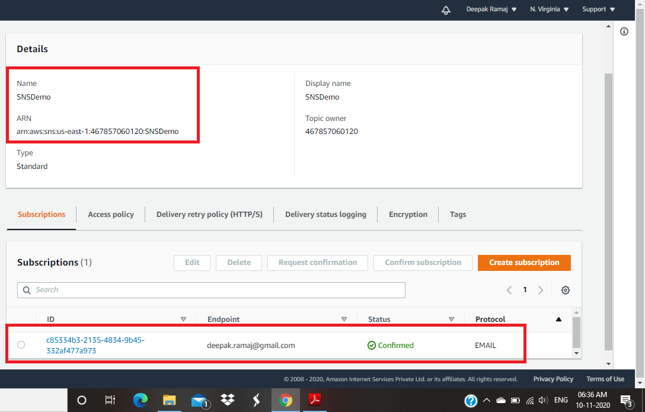

Fig. 1.1 SNS console

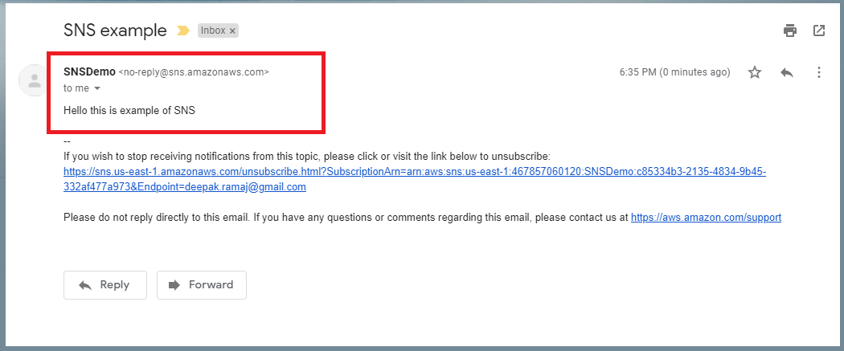

Fig. 1.2 Inbox with published message

Task 2: Working with SQS

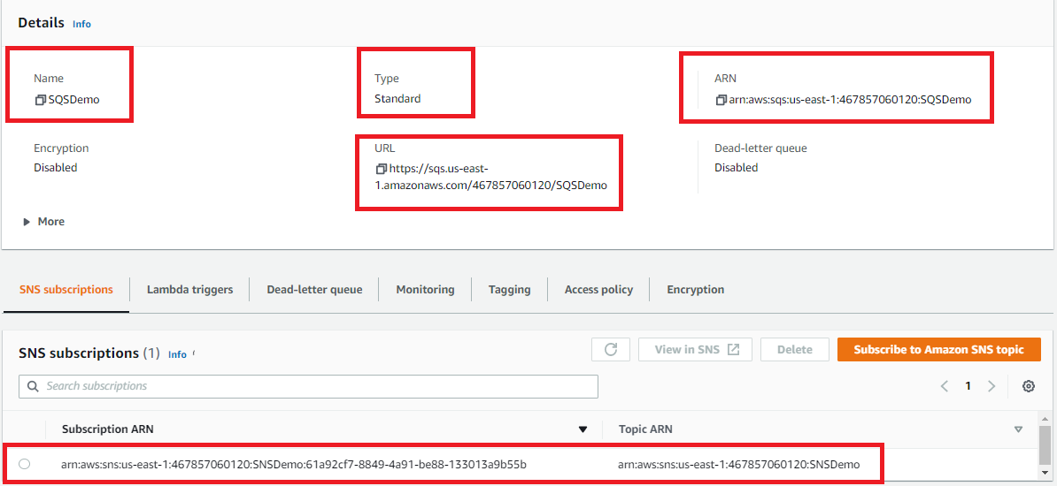

Fig. 2.1 SQS console

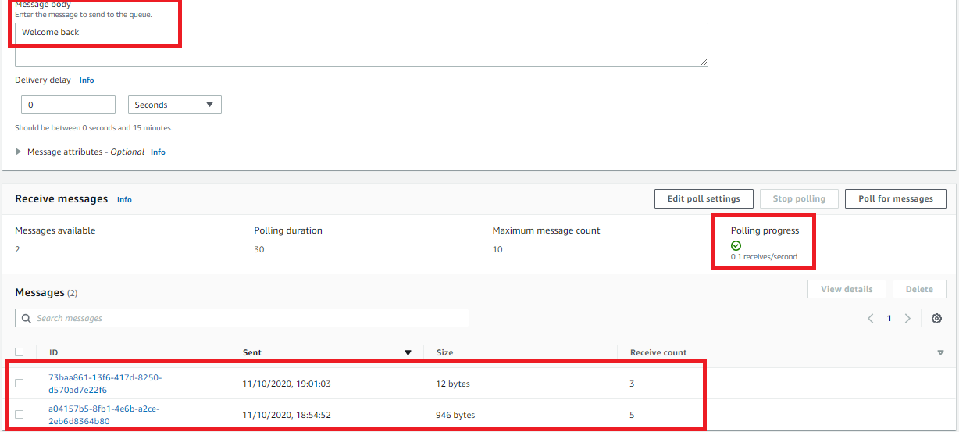

Fig. 2.2 Polling message

Task 3: Working with SES

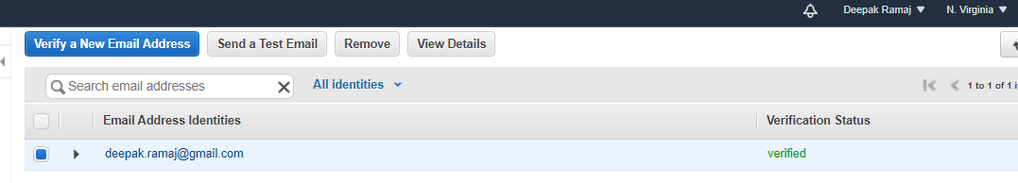

Fig. 3.1 Verification of eMail

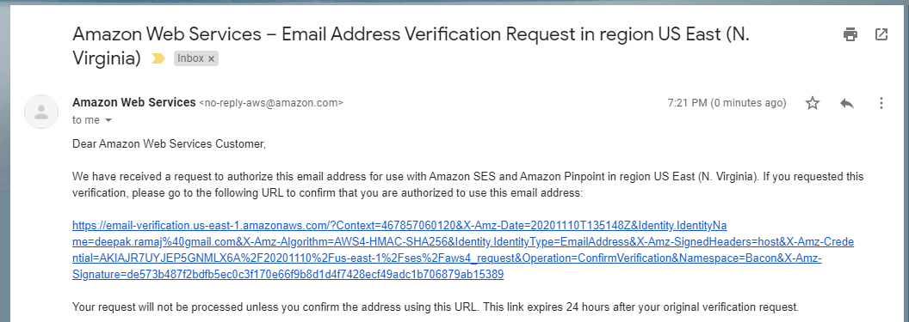

Fig. 3.2 eMail Inbox

DynamoDB Database

Task 1: Create a dynamo db table with minimum two disaster recovery zones and verify replication.

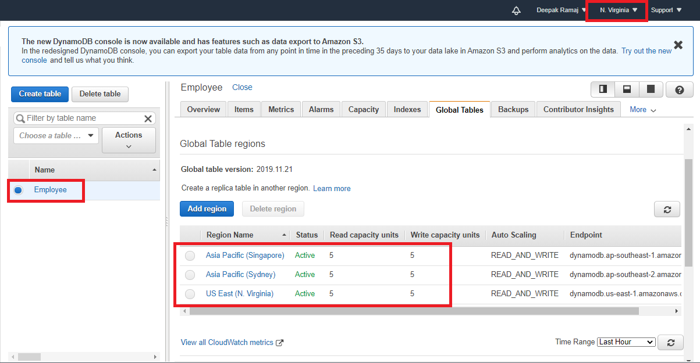

Fig. 1.1 Disaster Recovery Regions

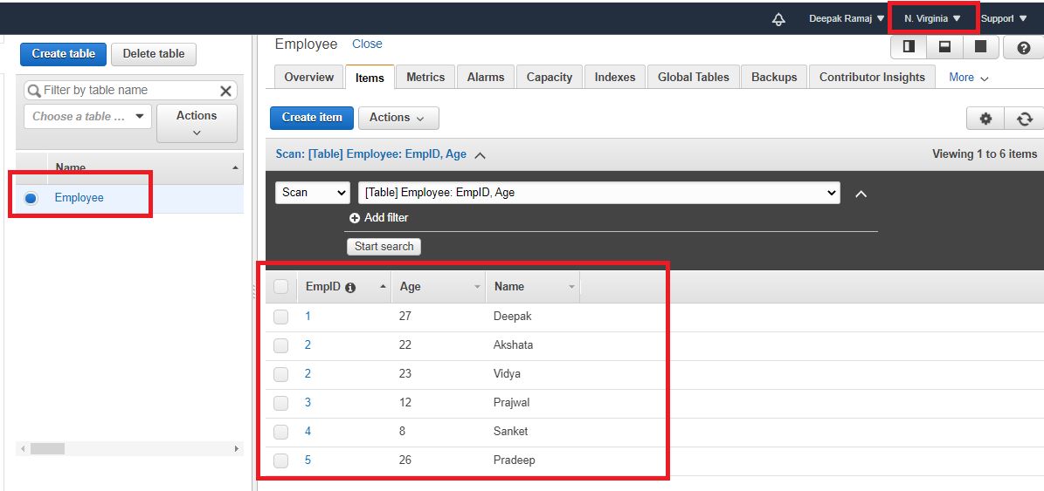

Fig. 1.2 Home region with item displayed

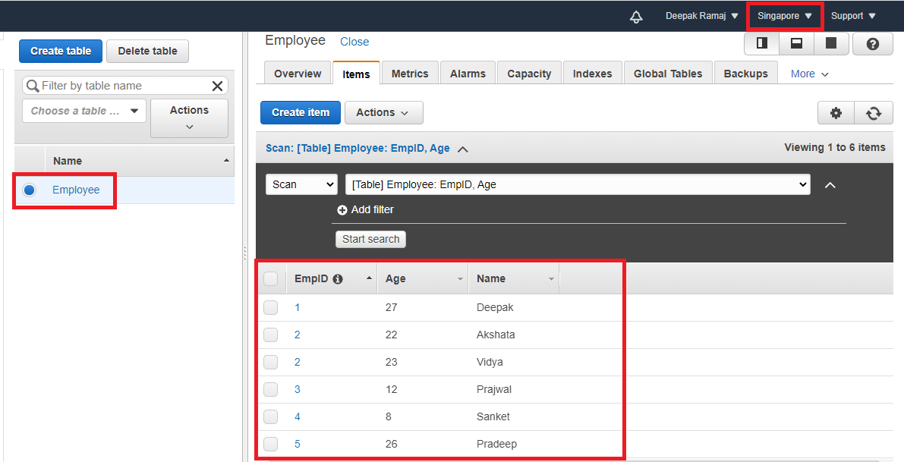

Fig. 1.3 Singapore region with item displayed

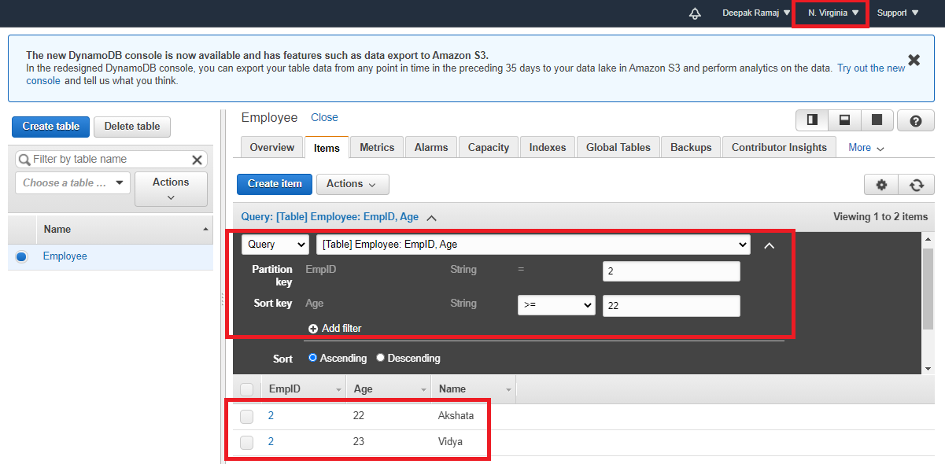

Fig. 1.4 User query to fetch items

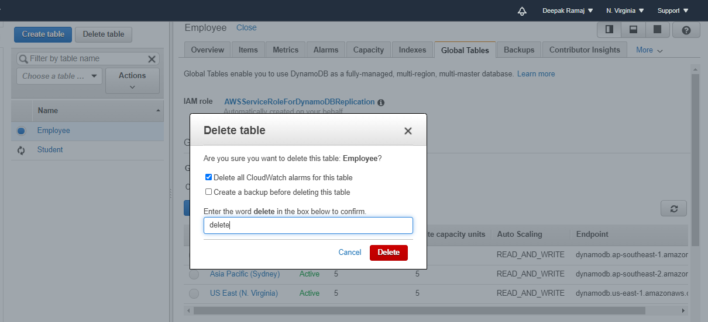

Fig. 1.5 Deletion of table

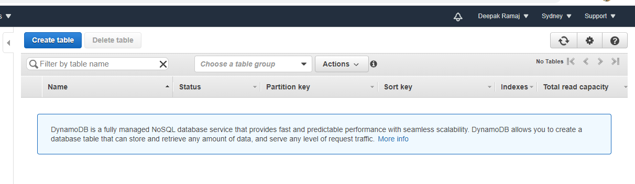

Fig. 1.6 Verification of table

Task 2: Creating a dynamo DB table with global secondary indexes and fetching data using global secondary indexes.

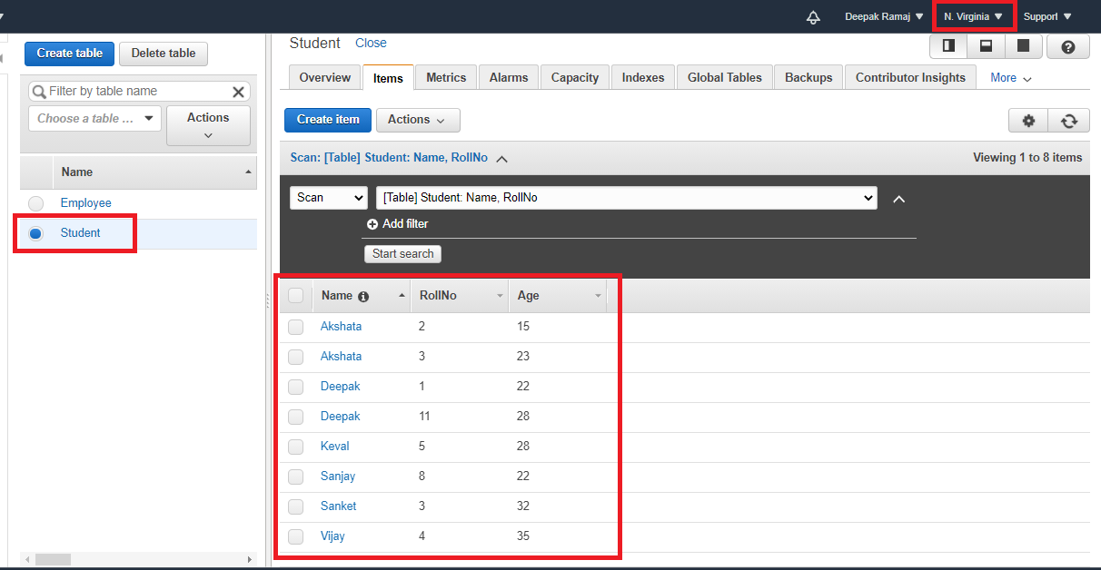

Fig. 2.1 Tables with items displayed

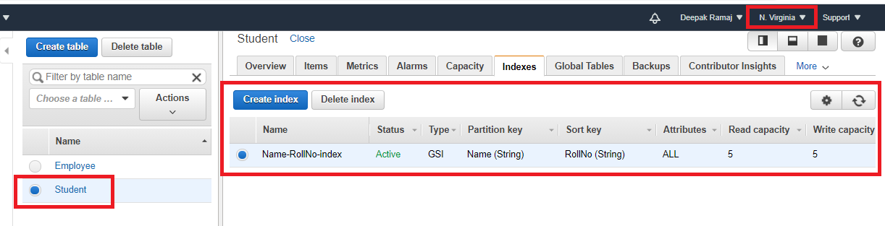

Fig. 2.2 Global Secondary Index (GSI)

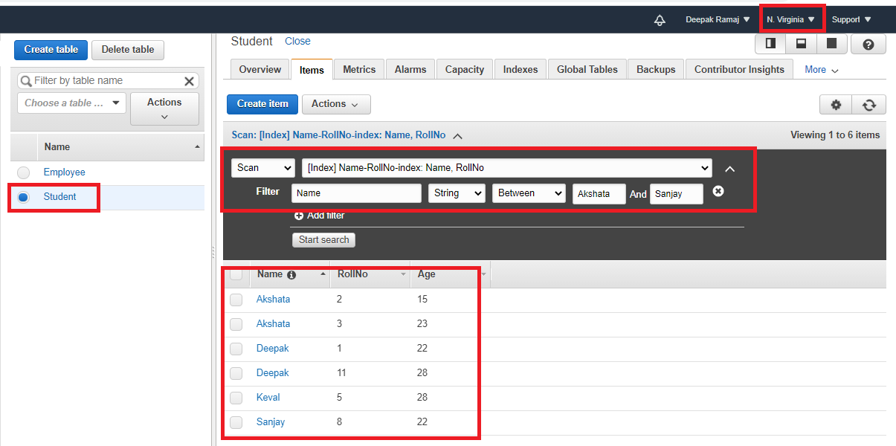

Fig. 2.3 Scan with Global Secondary Index (GSI)

Task 3: Deploying a python application in elastic beanstalk

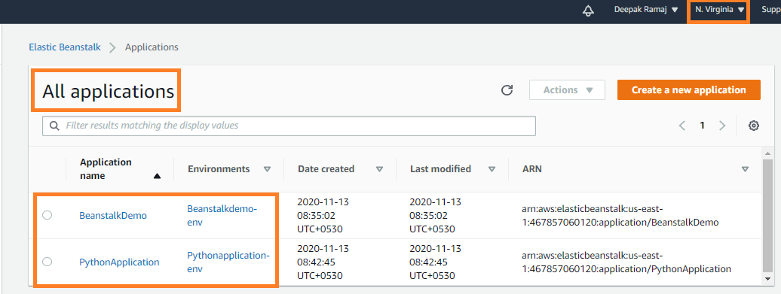

Fig. 3.1 Application page

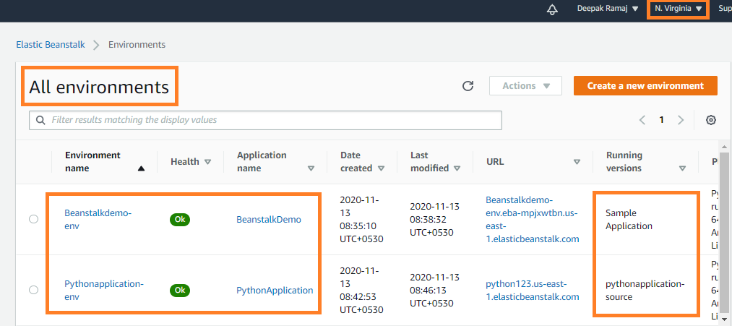

Fig. 3.2 Environment list page

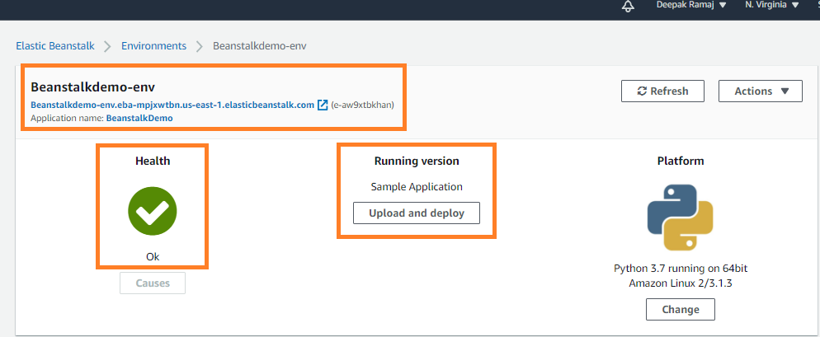

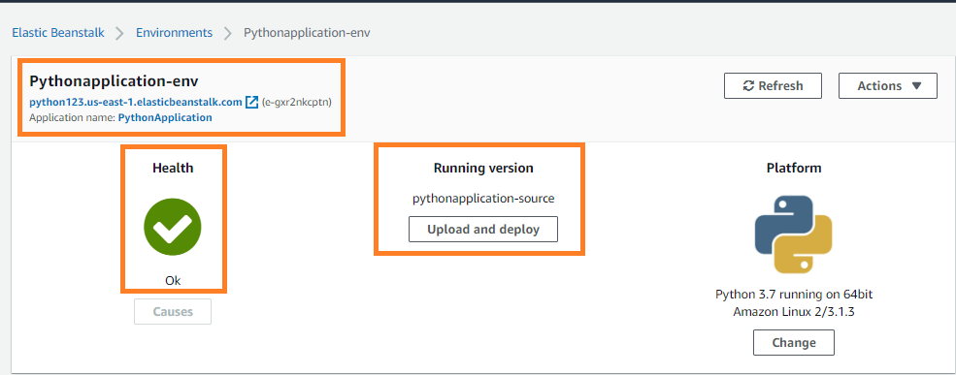

Fig. 3.3 Environment health check

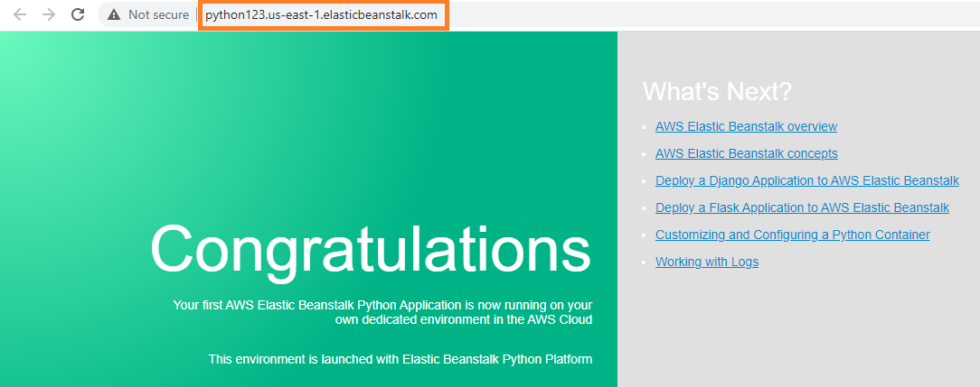

Fig. 3.4 Web page launched using the elastic beanstalk env